Live Streamer Technology Comparison
Environment: .NET 8
Technologies Compared: WebSockets, Kafka, Redpanda

1. Technology Overview
This section provides a brief overview of each technology being evaluated for live streaming in a .NET 8 environment.

WebSockets
WebSockets enable real-time, full-duplex communication over a single TCP connection. Ideal for lightweight, low-latency messaging.

Kafka
Kafka is a distributed event streaming platform designed for high-throughput and fault tolerance. Commonly used in enterprise-grade systems.

Redpanda
Redpanda is a Kafka-compatible streaming engine optimized for performance and simplicity, eliminating the need for JVM.

2. Performance Test Results
Screenshots and metrics from performance tests are included below for each technology across different message volumes.

Websockets

1 message
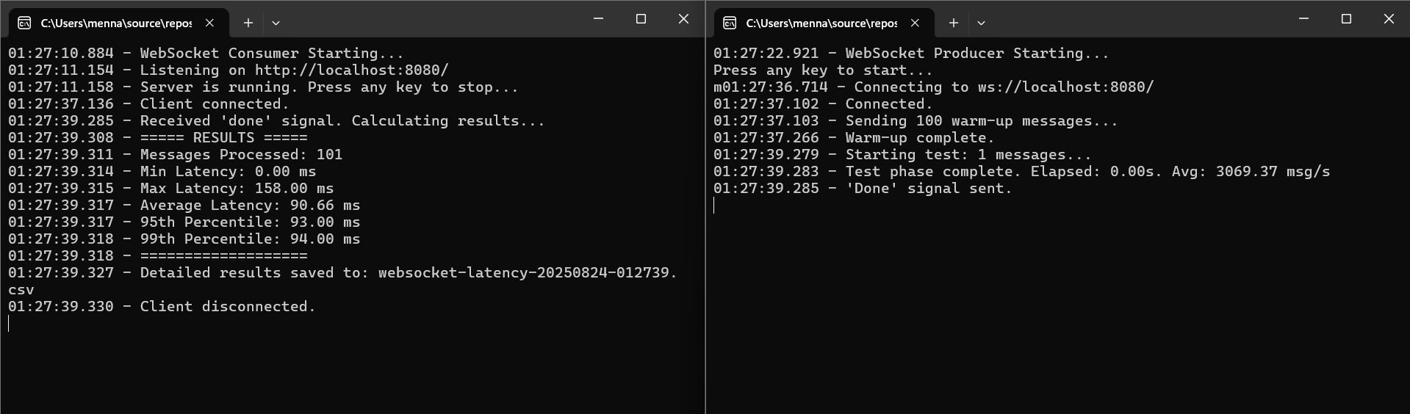

100 messages
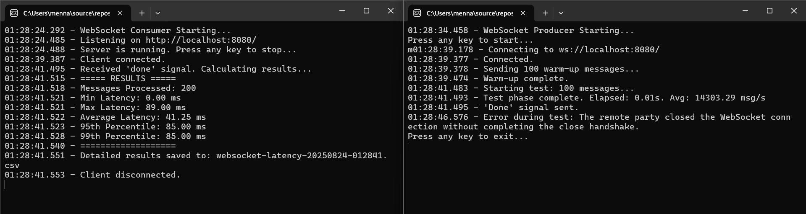

1 000 messages
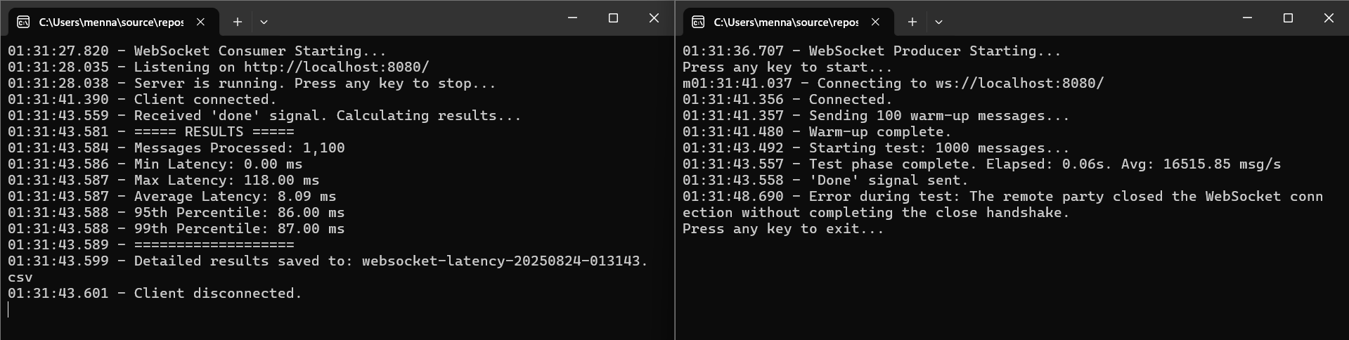

10 000 messages
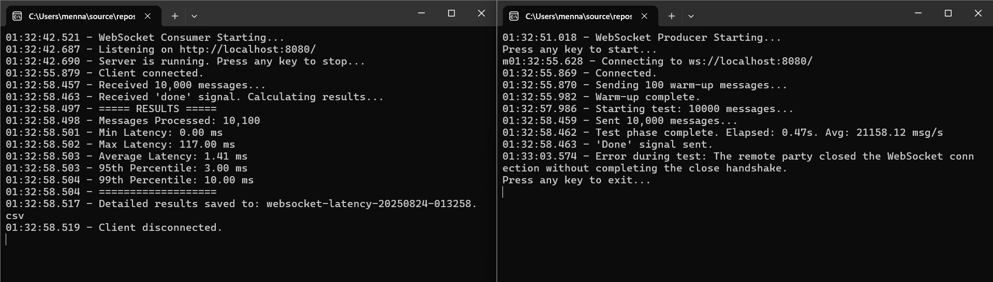

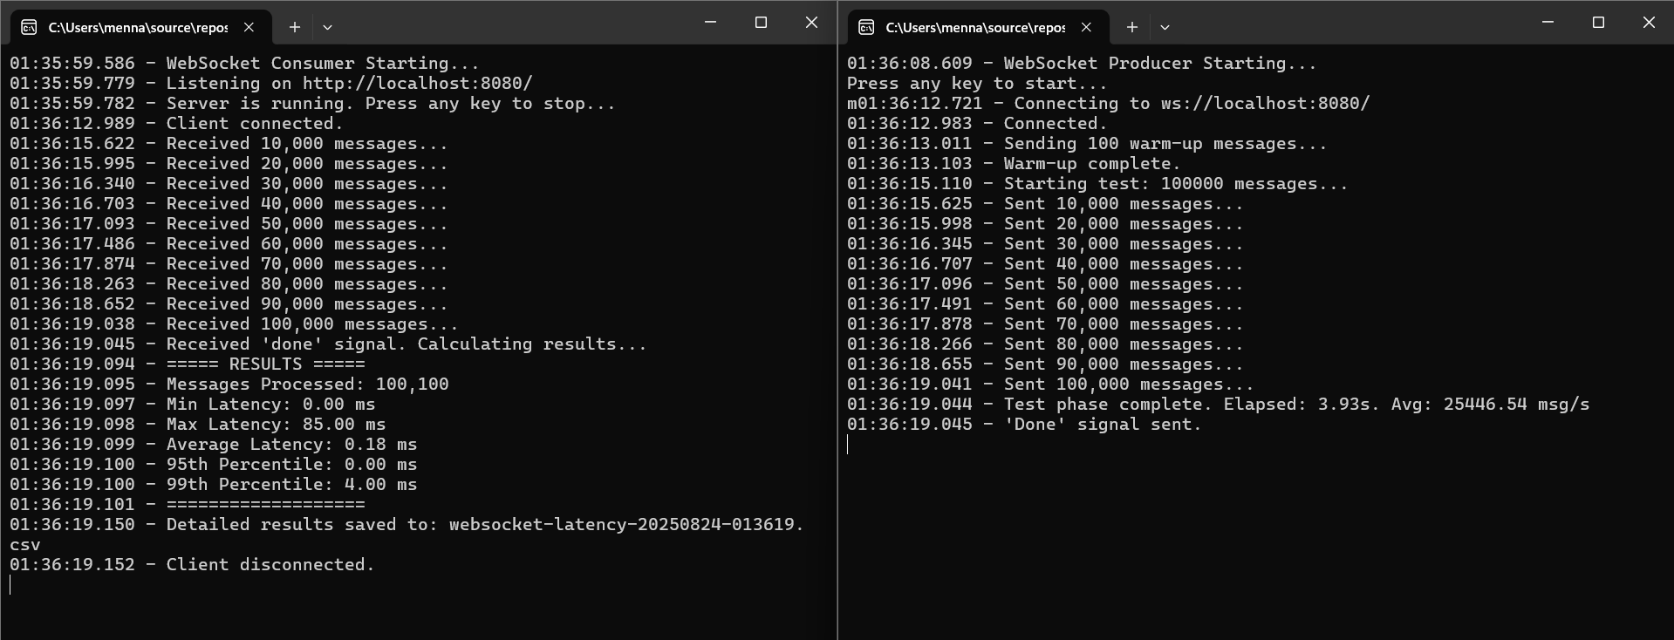
100 000 message

Kafka

1 message

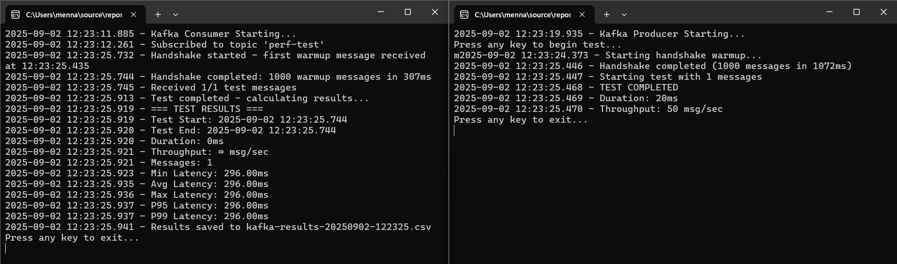

100 messages
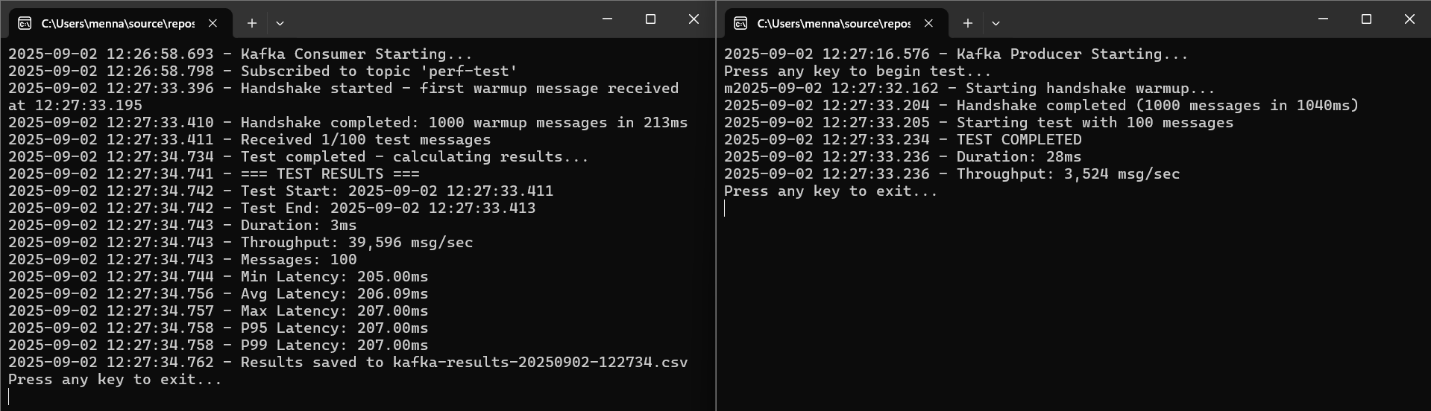

1 000 messages
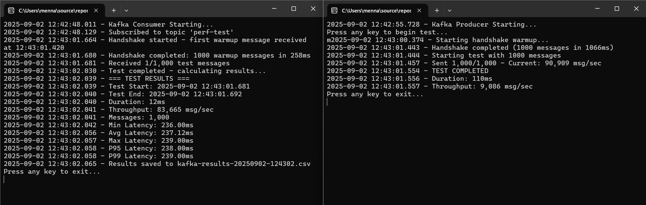

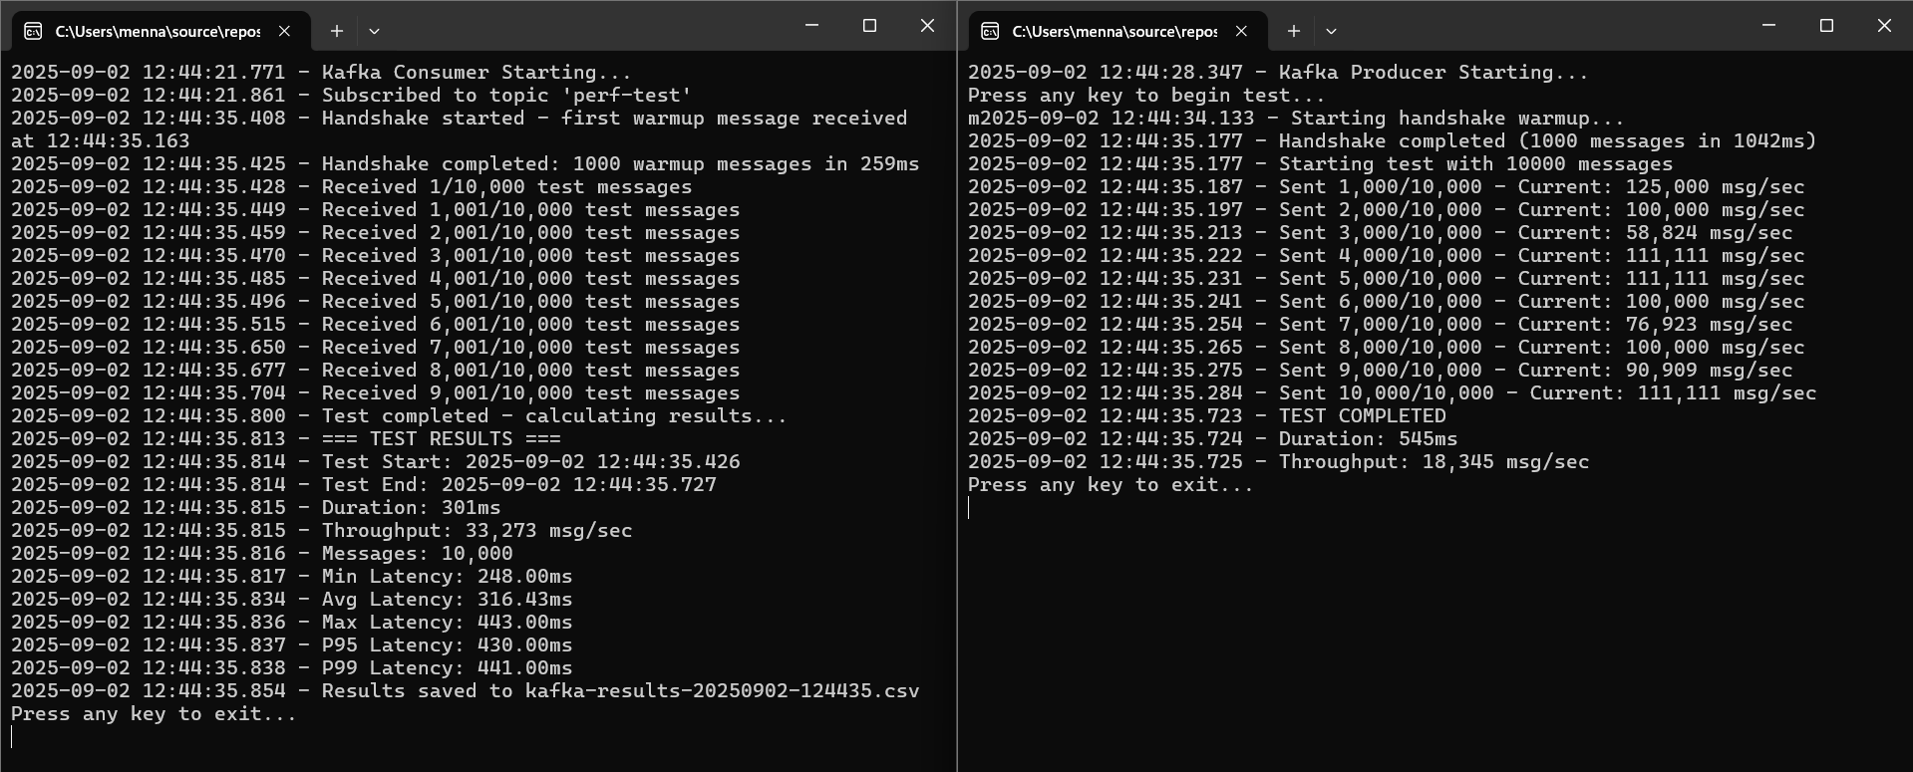
10 000 messages

100 000 messages

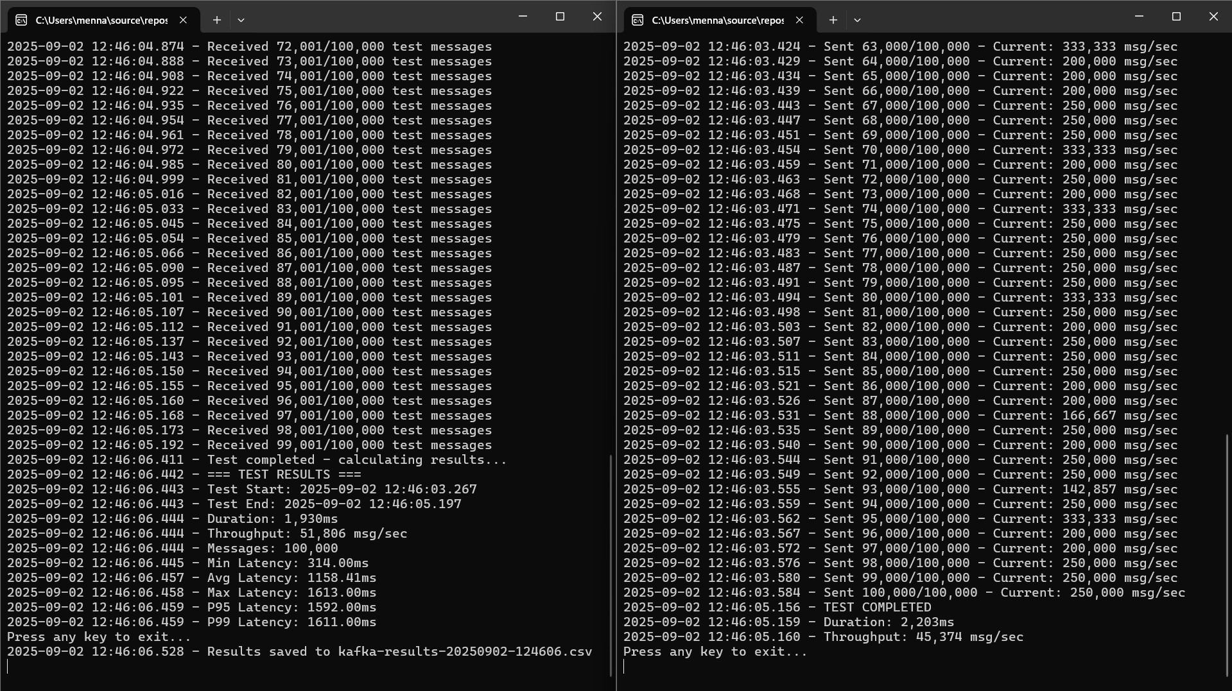

Redpanda

1 message

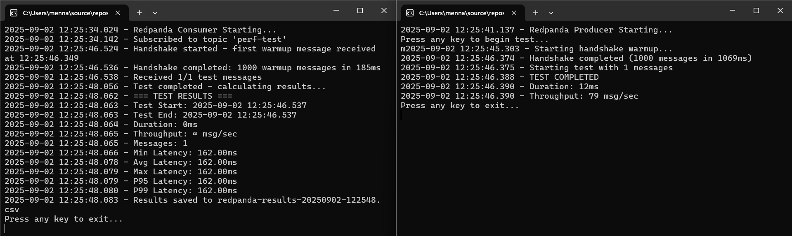

100 messages

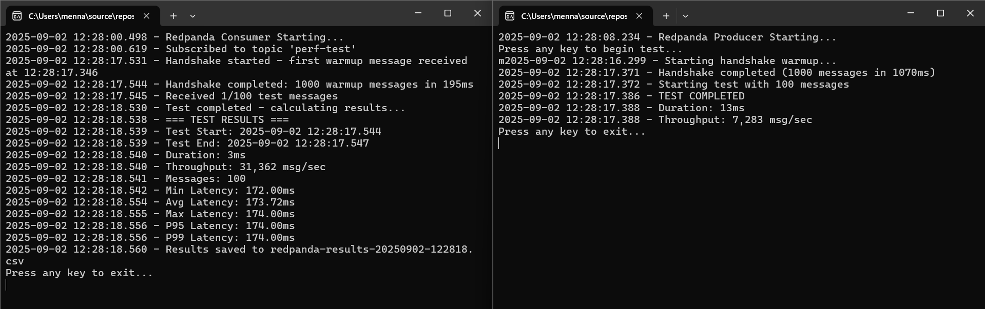

1 000 messages

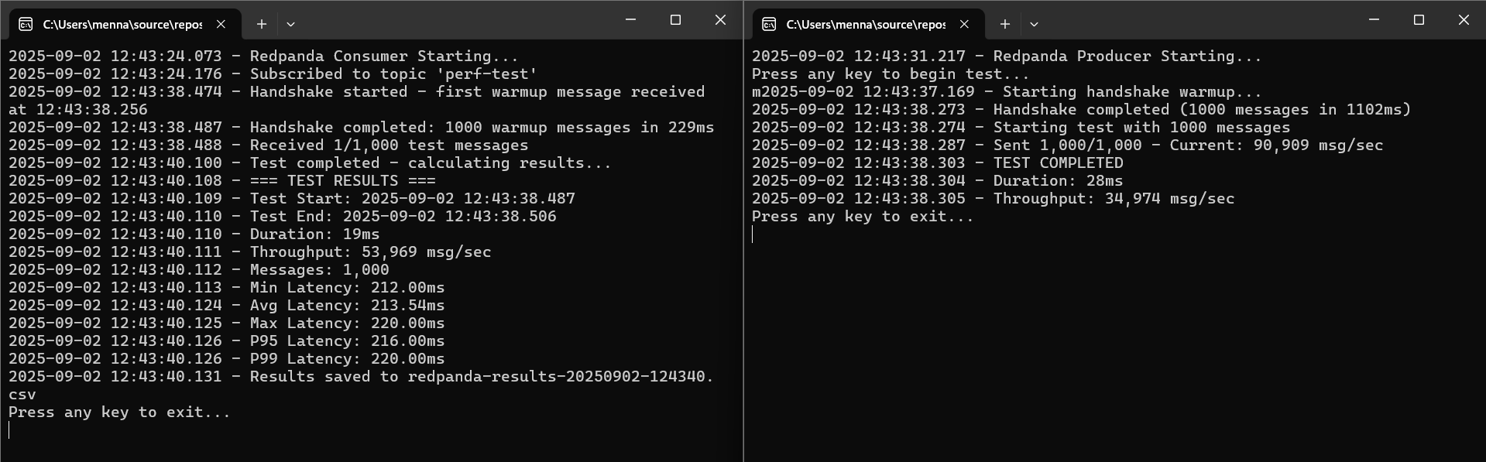

10 000 messages

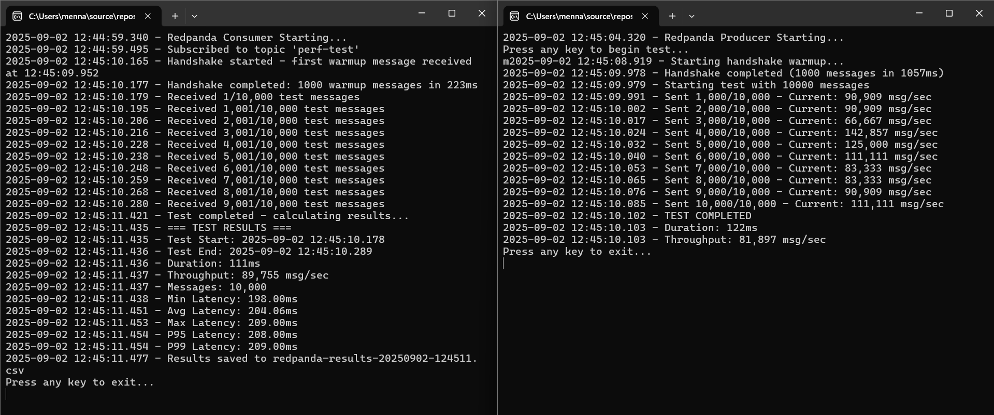

100 000 messages

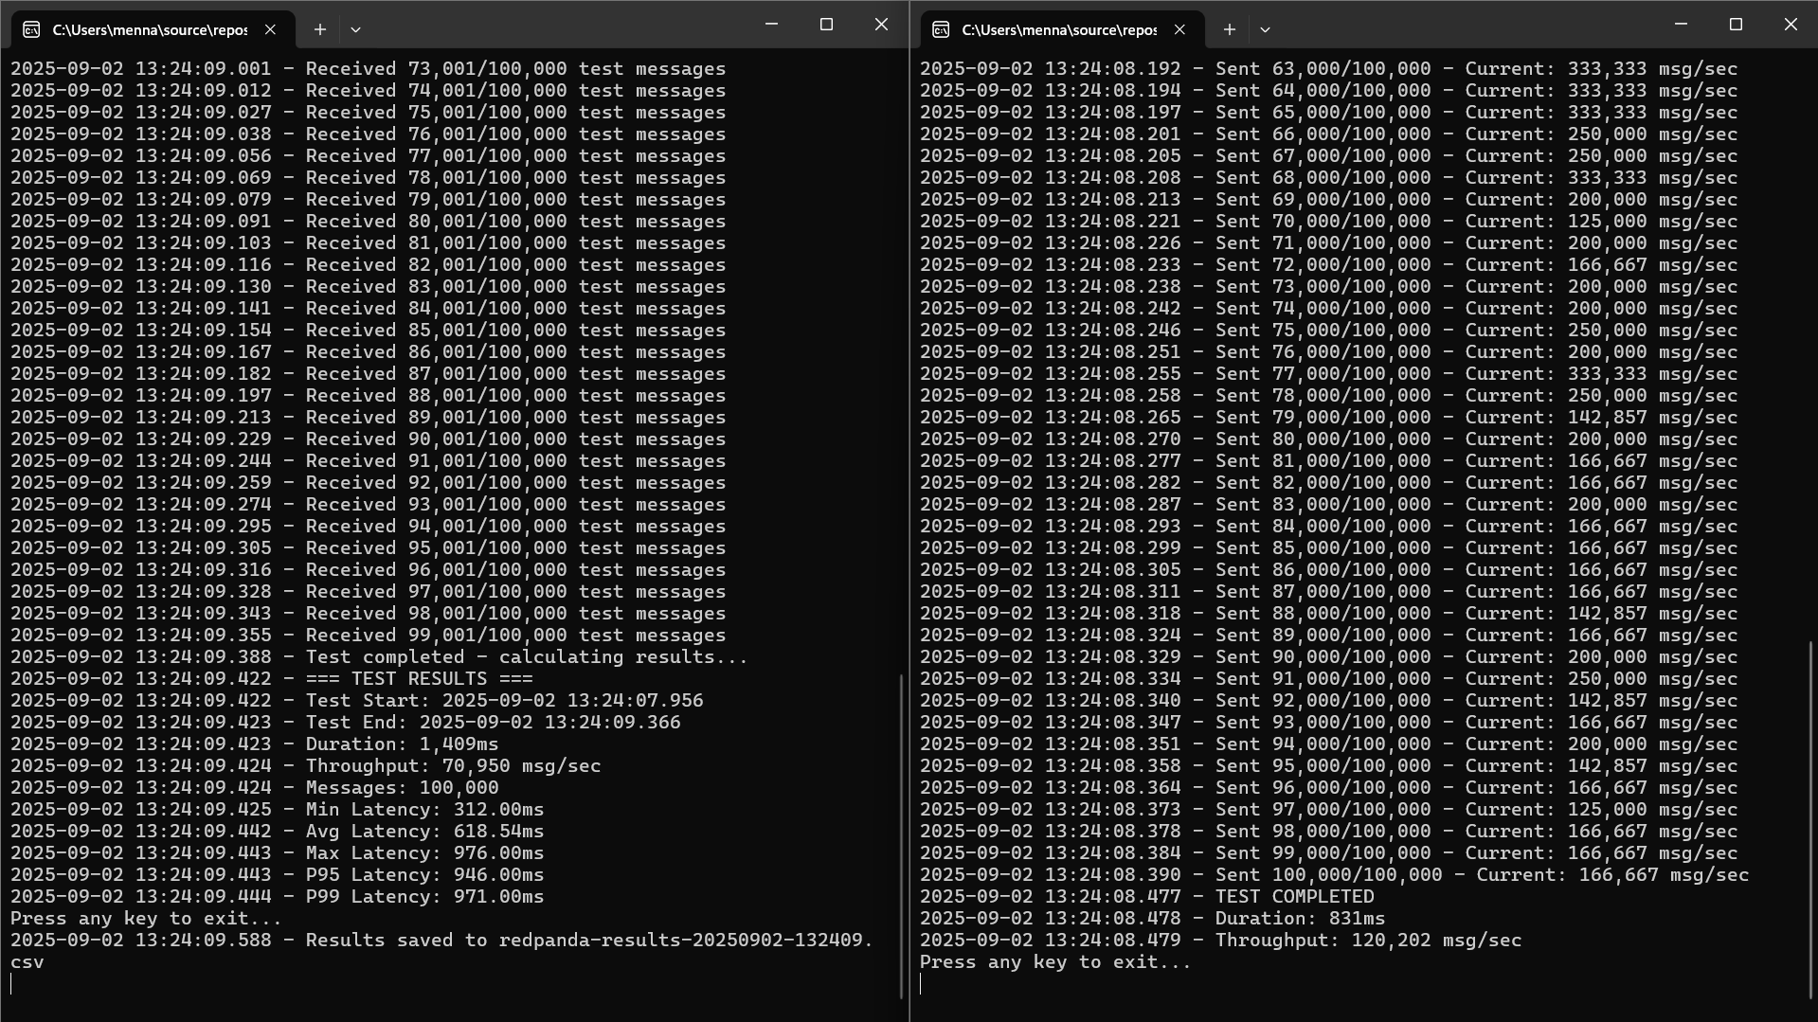

3. Pros vs. Concerns
Technology | Pros | Concerns
Websockets | - Simple  - Low-Latency | - No Persistence  - Hard to Scale
Apache Kafka | - Scalable  - Durable  - Mature ecosystem | - Complex setup  - JVM overhead
Redpanda | - Kafka-compatible  - Fast  - Simpler | - Newer technology  - Smaller community

4. Core Comparison
 | Websockets | Apache Kafka | Redpanda
Best For | Real-time UI | Event Streaming | High-Performance Streaming
Persistence | No persistence | Full persistence | Full persistence
Scalability | Very hard to scale horizontally | Excellent. Easy to scale horizontally by adding nodes | Excellent. Easy to scale horizontally by adding nodes
Decoupling | Tightly Coupled | Fully Decoupled | Fully Decoupled
Latency | Very Low | Low | Lowest
Throughput | Low | High | Highest
Ease of Use | Simple | Complex | Medium

5. License & Support
Technology | Free/Open Source | Enterprise Options | Support & SLAs
WebSockets | Native in .NET | N/A | Community support
Apache Kafka | Apache Kafka | Confluent Kafka | Full support, cloud options
Redpanda | Redpanda Community | Redpanda Enterprise | Full support, cloud options

6. Extra Features
Feature | WebSockets | Kafka | Redpanda
Security | TLS, | TLS, SASL, ACLs | TLS, SASL, ACLs
Monitoring | Custom | Kafka Manager, Prometheus | Built-in dashboard
Persistence | No | Yes | Yes
Replayability | No | Yes | Yes
Cloud Native | Yes | Yes | Yes
Infrastructure | App Server | Kafka + ZooKeeper | Single Binary
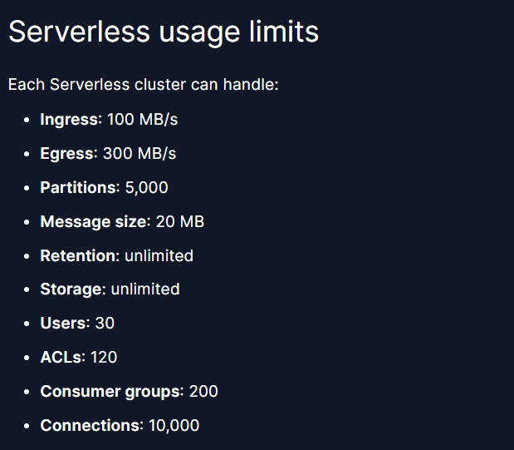

Redpanda Free Serverless Limitations:

6. Relevant Redpanda Resources
Redpanda:
NYSE_Cloud_Streaming_Factsheet.pdf Message from Redpanda Data
The NYSE sped up its realtime streaming data 5X with Redpanda | VentureBeat
Self-Host with Redpanda Enterprise | Redpanda
Redpanda Licensing | Redpanda Self-Managed Redpanda | Customers & Case Studies

,Menna Yasser

